Analyzing Data
Measurements of Central Tendency

Definitions:
Range – The difference between the greatest and least value in a set of data.

Ex. 1) Range for the data set 6,7,7,8,9 is 3 9 (highest) – 6 (lowest) = 3

- The range will give you an idea about how spread out the data set is. A low range indicates a data set where all the numbers are close together. Whereas, a high range indicates the numbers are more spread out.

Ex. 2) Calculate the range for the following set of data: 5.3, 2.4, 8.3, 9, 4.7, 3.9, 5.2

Median – The middle value in a set of data when the numbers are arranged in numerical order.

Ex. 1) What is the median of the set 4, 5, 1, 7, 3, 9, 10?

Ex. 2) What is the median of the set 10, 8, 15, 9?

Mode – The number that occurs the most often.

Ex. 3) What is the mode of the set 1, 5, 2, 6, 2, 6, 7, 2, 4, 6, 2, 6?

Ex. 4) What is the mode of the set 1, 4, 6, 6, 4, 3, 7?

Ex. 5) What is the mode of the set 1, 5, 6, 2, 4?

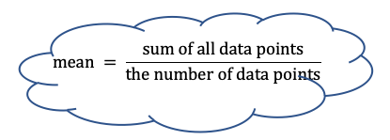
Mean – The average value determined by sharing the sum evenly among the values in the set.

Ex. 1) Calculate the mean for the data set 4, 6, 7, 2, 10.

Ex. 2) The results of grade 7 math test were 87%, 85%, 92%, 98%, 100%, 89%, 95%. Is the mean a good representation of how the class did?
Ex. 3) Consider the data set 8, 4, 7, ____, 11. The mean of this set is 7. What is the missing value?

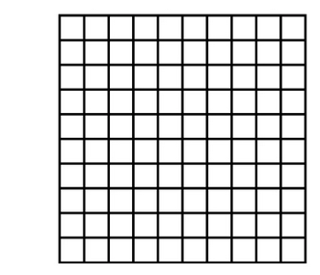
Outliers – A data value that is far from the other data values.

Ex. 1) Jill entered a math competition and received the results below. Show the results on as a broken line graph.

55%, 99%, 75%, 75%, 75%, 82%, 90%, 84%, 88%, 80%

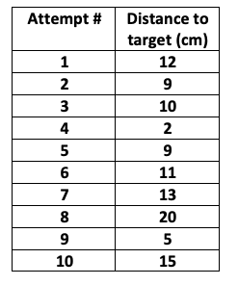
Ex. 2) John tossed a ball at a target on the floor 20 ft. away. He marked where each attempt landed and measured how far these marks were from the target. His results are given below.

- Create a line plot showing the results.

- Which points might be considered outliers? If I want to determine what is John’s typical accuracy, should we include these measurements?

- Calculate each of the measurements of central tendency. Using the data, what is John’s typical accuracy? Explain.

  - Mode –

  - Median –

  - Range –

  - Mean –
Measurements of Central Tendency
Accuracy

Purpose: To determine who has the most accurate tosses in a group.

Hypothesis: State a hypothesis using a complete sentence. Based on the evidence you have, who do you predict is the most accurate?

Variables: State the variables for the experiment
Independent Variable _________________________
Dependent Variable _________________________
Control Variables (min. 3) ________________________, _________________________,
_________________________

Procedure
- Mark a line indicating where you will toss from. Mark a target with an “X” about 10m away.
- Toss the ball at the target and have a group member mark where the ball lands.
- Repeat until you have completed 10 tosses.
- Measure the distance from each mark to the target in cm and record in the data table.
- Complete the results and analysis.

Results and Analysis

Data Table – Record the distance in cm.

Group Members’ Names
Attempt #
1
2
3
4
5
6
7
8
9
10
- Graph each group member’s results on an individual line plot below using a different colour and include a legend.

Legend (colour in small box, name in large box)

- Circle, with pencil, an example of an outlier on the line plot.

- Determine the range, median, mode, and mean of each group member’s results. Record this in the table provided. Include a sample calculation.

Group Member’s | Range | Median | Mode | Mean
Who had the best value?

Sample Calculation:
Range | Median | Mean

Conclusion: Based on the data you collected, who had the most accurate throws? Support your answer with actual numbers.

Graphing

The following data shows the number of push ups Billy did each day during the week. Create a broken line graph showing his results.

Monday | Tuesday | Wednesday | Thursday | Friday | Saturday | Sunday
54 | 64 | 52 | 75 | 0 | 68 | 72

- Are there any outliers in the data set? Should outliers be included in the calculations of central tendency?

- What is the typical number of pushups Billy did during the week?

Support your answer by Calculating the range, median, mode, and mean.

Range | Median
Mode | Mean

