UNIT 9: Measurement and Geometry

TOPICS:
- 5.1 The Area of a Parallelogram
- 5.2 The Area of a Triangle
- 5.4 Calculating Circumference
- 5.6 Calculating the Area of a Circle
- REVIEW Plotting Points
- 7.2 Comparing Positions on a Grid
- 7.3 Translations and Reflections
- 7.4 Rotations

5.1 The Area of a Parallelogram
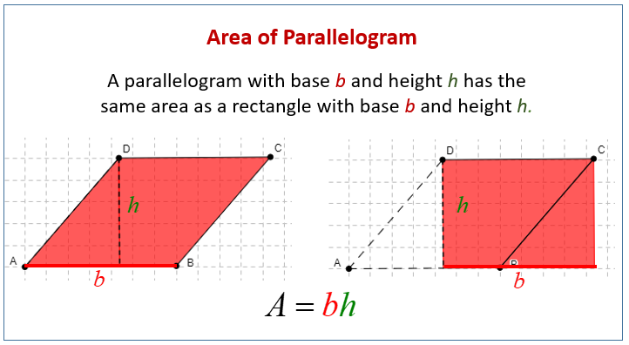
$Area = base x height$

Units for Area square units
mm², cm², m²

The base and height must be perpendicular.

Perpendicular – Meet at right angle (90º)

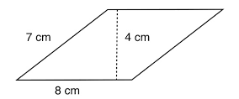
Ex. 1) Calculate the area of the parallelogram given.

Ex. 2) The area of a parallelogram is 42 cm². If it has a base of 4 cm, what is the height?

Ex. 3) Draw 2 different parallelograms that have an area of 32 m².

ASSIGNMENT: ___________________________

5.2 The Area of a Triangle
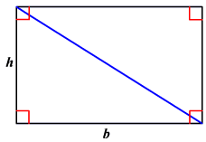
The area of a triangle will be half the area of a rectangle or parallelogram.

$$Area ∆=\frac{1}{2}base x height$$

Reminder – The base and height must be perpendicular.

Ex. 1) Calculate the area of the triangle given.

Ex. 2) The base of a triangle is 14 mm. The area of this triangle is 56 mm². What is the height?

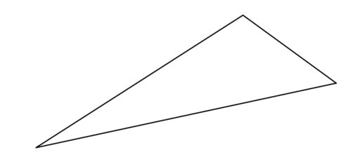

Ex. 3) Use a ruler to calculate the area of the triangle 2 different ways.

Ex. 4) The perimeter a right-angle triangle EFG is 14 cm. EF = GF = 10cm. What is the area of the triangle?

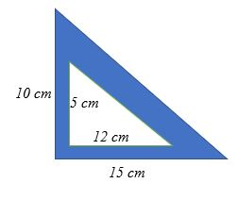

Ex. 5) Find the area of the shaded region given in the diagram. What are you assuming about the triangle?

ASSIGNMENT: ___________________________

5.4 Calculating Circumference
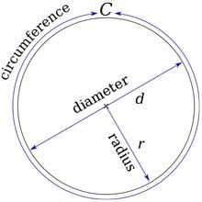
Circumference – the boundary of a circle.

Diameter – The longest line segment that can be drawn inside a circle.

Radius – The distance from the circle of the circle to any point on the circumference. It is half the diameter.

$π (pi)$– The ratio of the circumference of a circle to the diameter.

The circumference of a circle is equal to $π$ times the diameter. $C=πd$

Ex. 1) Determine the circumference and diameter of a circle with each radius.

- 5 cm b.) 7 mm

Ex. 2) Measure the radius, diameter, and circumference of the circle with a ruler.

Ex. 3) Determine the perimeter of the field on the right.

Ex. 4) What is the distance B? The circumference of the large circle is 50.24 cm. Distance A is 7 cm.

ASSIGNMENT: ___________________________

5.6 Calculating the Area of a Circle
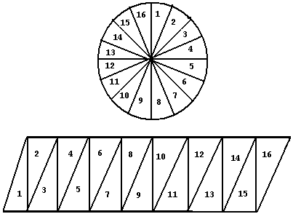
We can estimate the area of a circle by cutting it up into smaller triangular sections. The more sections, the better the estimate. When arranged together, they make a parallelogram. This parallelogram will have the same area as the circle.

The base of the parallelogram has a length of 1/2 the circumference or $\frac{1}{2}πd = \frac{1}{2}π(2r)=πr$

The height of the parallelogram has a length of r. So, the area of the parallelogram or circle is given by $πr∙r =πr^{2}$

$$A(circle)=πr^{2}$$

Ex. 1) Calculate the area given the following information.
- Diameter = 10 cm b.) Radius = 25 mm

Ex. 2) Measure the area of the circle on the right using a ruler.

Ex. 3) Determine the area of half a circle with a diameter of 40 cm.

Ex. 4) Determine the area of the shaded region for A, B, and C.

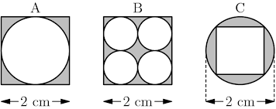

ASSIGNMENT: ___________________________

REVIEW Plotting Points

The x coordinate describes the horizon distance from the origin.

The letter in the front labels the point. A(x,y)

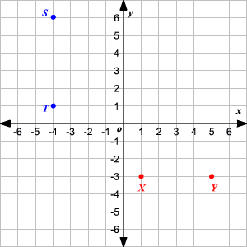
The y coordinate describes of vertical distance from the origin.

Ex. 1) Write the coordinates for r, s, x ,y.

Ex. 2) Plot each of the following points on the grid.
A(3,4), B(-2,-5), C(4,-1), D(-4, 3)

Ex. 3) What is the coordinate of the origin?

Ex. 4) What is the x coordinate for all points on the y-axis? Give 3 examples.
Ex. 5) What is the y coordinate for all points on the x-axis? Give 3 examples.

ASSIGNMENT: ___________________________

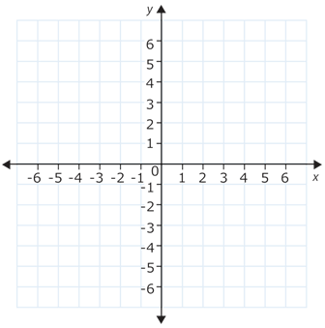
7.2 Comparing Positions on a Grid

Ex. 1) On the grid given, draw each of the following lines.

- x = -3 b.) y = 4

Ex. 2) Complete the sentence using above or below.

- F(4,-5) is _____________ G(1,3)

- H(3,9) is _____________ I(5, 3)

Ex. 3) Which of the three points is further to the left? How do you know?

J(3,2), K(-4,5), L(1,4)

Ex. 4) A triangle is formed from the points A(1,1), B(6,1) and C(6, 4).
- What is the base and height of this triangle?

- What is the area?

Ex. 5) What is the horizontal distance between point C(-5,-2) and D(4,-2)?

ASSIGNMENT: ___________________________

7.3 Translations and Reflections

Translation – moves every point of a figure by the same distance in a given direction.

A(3,4) A’(4,6) 1 unit to right, 2 units up

Reflection – is the mirror point on the opposite side of the axis.

G(-5,2) reflected through y = 0 G’(-5,-2)

Ex. 1) Describe the translation that moves ABC to A’B’C’

Ex. 2) Points J(0,3), K(-5,-3), L(1,-4) were reflected across the y-axis. Draw J’K’L’

Ex. 3) $ΔDEF$ is transformed to $ΔD"E"F"$by applying the same translation twice. The coordinates for D was (-4, 3). Describe the translation and draw $ΔDEF.$

Ex. 4) The rectangle ABCD is reflected across the line x = 2. Draw the rectangle A’B’C’D’.

ASSIGNMENT: ___________________________

7.4 Rotations

Rotation – rotates points around a centre of rotation.

Centre of Rotation – a fixed point which other points in a shape rotate in a clockwise (CW) or counter-clockwise (CCW) direction.

Clockwise (CW)

Counter-Clockwise (CCW)

Ex. 1) Rotate each point 90º CW around the origin. Write the coordinates of the new point.

- A(2,0)

- B(0,4)

- C(-5,0)

- D(-6,0)

Ex. 2) Rotate the rectangle EFGH 90º CCW around the origin. Draw and label the new shape.

Ex. 3) Rotation the points in the $Δ$JKL 90º CW around J.

ASSIGNMENT: ___________________________

