Name: __________________

Assignment 3.3
Generating Electricity from Water

Read Section 8.3 and complete the following.

- What makes BC an area suitable for hydro power?

- List 3 places in the world where hydro would be a good choice for power generation.

- List 3 places in the world where hydro would not be a good choice.

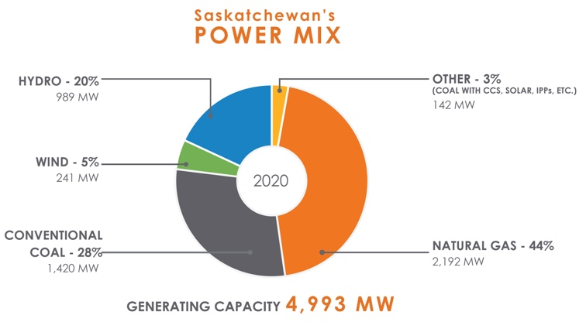
- Why do you think Saskatchewan generates power using mostly natural gas and coal?

- Describe in words how water used to generate electricity?

- What do you think is the most important pro and con of using water to generate electricity?

Pros

Cons
- Label the diagram and indicate the purpose of each of the following:

Reservoir | Penstock
Turbine | Generator
Spillway | Dam
Transmission lines

