How is Electricity Generated?

- Electricity can be produced from many different energy sources.
  - Examples include: Water, Wind, Sun, Waves, Geothermal

- These are examples of renewable resources. They can be used repeatedly and do not run out because they are naturally replaced over a short period of time.

- Wood is considered a renewable resource if it is being used in a sustainable way. A tree is carbon neutral over its lifetime.

- Other energy sources like fossil fuels (coal, gas, and oil) and nuclear, are non-renewable. Once these resources are used up, they cannot be replaced over a short period of time.

- All these sources generate electricity using the same principle.
  - The different energy sources are used to turn a turbine.
  - The turbine powers a generator.
  - The generator creates electricity.

Diagram of a Turbine | - Steam, wind, or falling water can be used to turn the shaft of the turbine.
Diagram of a Generator | - Attached to the end of the shaft are powerful electromagnets. The rotating shaft spins the magnets.  - As the magnets pass the coils of wire, they produce electricity.

Assignment 3.1 – How is Electricity Generated?
Activity 1 – Making a Mini Generator

Getting Electricity to Your Home

- Once electricity is generated at the power station, it is carried by transmission lines. The power leaving the power station is very high voltage so that less energy is lost as it is carried into the cities.
- As it enters communities, transformers lower the voltage, so it poses less of a threat to humans. It is still too high of a voltage to enter your home, so other transformers are needed to further lower the voltage.
- Three wires enter your home through an electric meter. Electricity companies use this meter to measure the amount of electricity consumption in the home.
- The amount of electricity used in a home varies from day to day, depending on the weather, and/or activities in the home.
- The maximum voltage used in a home is 240V. This is needed by large appliances like dryers, hot tubs, and stoves.
- Most appliances like microwaves, lights, computers, and TVs are run on 120V.
- Much of our power grid is buried underground in cities.

Summarize the information above using Assignment 3.2

Generating Electricity from Water
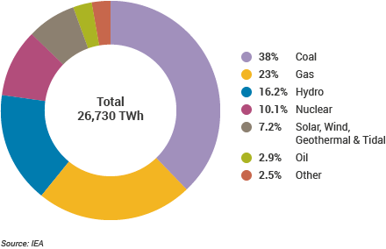
- About 90% of B.C.s electricity is produced using hydroelectric energy.
- Worldwide, about 16% is produced.
- Hydroelectric dams are used to change energy of moving water (gravitational potential energy) into electricity.

Pros  - Renewable energy source.  - Do not produce pollution or greenhouse gases.  - Once built, they are very inexpensive to operate.  - The reservoir helps control flooding and provides water during droughts. | Cons  - Often require flooding large areas of land to build dam.  - Can disrupt local ecosystems and are barriers to migrating fish.  - Expensive upfront costs.  - Decreased capacity during droughts.

Summarize the information above using Assignment 3.3

Generating Electricity from Non-Renewable Resources
There are several main types of non-renewable resources we use to generate power.

- Coal
- Oil and Gas
- Nuclear

Electricity from Fossil Fuels

- Coal, crude oil, and natural gas are all considered fossil fuels because they were formed from the fossilized, buried remains of plants and animals that lived millions of years ago. Because of their origins, fossil fuels have a high carbon content
- In power generating plants, fossil fuels are burned to heat water and produce steam. The steam is used to turn a turbine.

Combustion Chemical Reaction:

Some carbon chain + oxygen carbon dioxide and water

- Coal contains the energy stored by plants that lived hundreds of millions of years ago in swampy forests. Layers of dirt and rock covered the plants over millions of years. The resulting pressure and heat turned the plants into the substance we call coal.

- Natural gas was formed millions of years ago when heat and pressure transformed decaying plant and animal matter buried in sedimentary rock layers. Normally, natural gas is trapped under layers of rock that prevent it from flowing easily to the surface.

- Oil is formed from the remains of living organisms that fell to the seafloor millions of years ago. Time and organic sediments, in addition to other factors, aided the decomposition of this material and produced hydrocarbon.

Pros  - Cheap fuel source  - Can be built anywhere | Cons  - Not sustainable  - Burning fossil fuels produces greenhouse gases and puts dangerous pollutants into the air.

Electricity from Nuclear Fuel

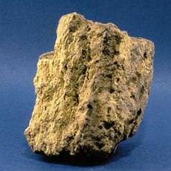
- Most nuclear power stations use uranium as a fuel to create nuclear energy.

- Naturally occurring uranium ore is a mixture found in the earth’s crust and needs to be purified before it can be used to produced energy. Uranium-235 is the only naturally occurring material which can sustain a fission chain reaction, releasing large amounts of energy.
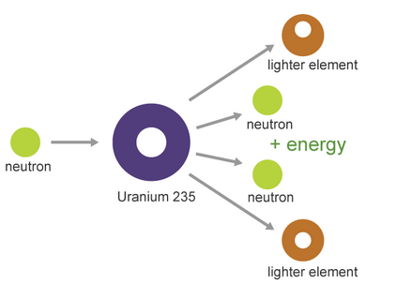
- The isotope Uranium-235 is important because under certain conditions it can readily be split, yielding a lot of energy. It is therefore said to be 'fissile'.

- In a nuclear reactor the uranium fuel is assembled in such a way that a controlled fission chain reaction can be achieved. The heat created by splitting the Uranium-235 atoms is then used to make steam which spins a turbine to drive a generator, producing electricity.

Pros  - Very efficient at producing electricity  - Do not cause air pollution or release greenhouse gases. | Cons  - Uranium is radioactive and harmful to all organism.  - They produce waste that remains radioactive for thousands of years and therefore must be stored carefully.  - Nuclear plants have blown up in the past. This releases large quantities of radioactive material into the air and water.

