Qualitative Observation vs. Quantitative Observation

Qualitative Observation - You observed a quality about an object.
It smelled good, it was green, etc.

Quantitative Observation - Observations that it can be described or measured in concrete numerical terms.
There are 30 students in my class. I weigh 98 pounds. I ate a pound of potatoes.

Determine which of the following statements are (qN) quantitative and which are (qL) qualitative.

- The temperature outside is 250ºC. _____
- It is warm outside. _____
- The tree is 30 feet tall. _____
- The building is taller than the tree. _____
- The sidewalk is long._____
- The sidewalk is 100 meters long._____
- The race was over quickly. _____
- The race was over in 10 minutes. _____

Observation and Inference
Match each statement with either (Ob) observation or (I) inference.

An observation is something you sense: taste, touch, smell, see, or hear. An inference is
something you decide or think about a thing or event after you observe it.
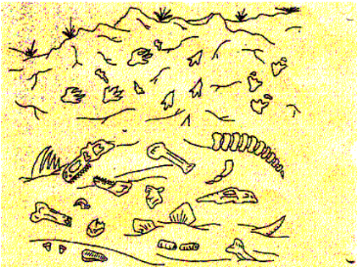
- The Camptosaurus is leaving tracks in the ground.
- There are plants growing in the water.
- There is a tree growing next to the river.
- The climate is warm.
- The Stegosaurus is eating the plant.
- There are bones from a dead animal by the shore.
- Lava is corning down the sides of the volcano.
- The Camptosaurus has sharp teeth.
- The Camptosaurus has sharp teeth for eating meat.
- The Camptosaurus is going into the water to eat the plants.

