Name: ______________________________________ Date: ________________________

Student Exploration: Plate Tectonics

Prior Knowledge Questions (Do these BEFORE using the Gizmo.)

- Volcanoes are openings in Earth’s crust where lava, gas, and ash can erupt. Where are most active volcanoes located?

- An earthquake is a violent shaking of Earth’s surface. Where are earthquakes most common?

Overview:
Volcanoes, earthquakes, mountains, and other features of Earth’s surface owe their origin to the movements of plates: enormous, slowly-moving sections of Earth’s crust. At plate boundaries, plates collide, move apart, move under or over each other, or slide past one another. The theory of plate tectonics describes how the plates move, interact, and change the physical landscape.

ACTIVITY A: Sliding Plates

Question: What happens when plates slide past one another?

- Observe: Boundary A is a transform boundary. The arrows below the BOUNDARY A label will move the plates. Click the left arrow once to see how the plates move. How would you describe the motion of plates in a transform boundary?

- Sketch: Draw a bird’s-eye view of the plate boundary before and after the plate motion. Draw an arrow to show which way the plate moved.

Before movement After movement

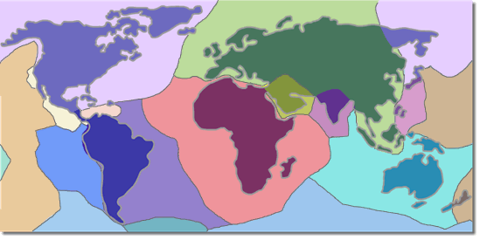
- Locate: Turn on Show location. Highlight these locations on the map below.

ACTIVITY B: Colliding Continents

Question: What happens when two continents collide?

- Observe: Boundary B is an example of a convergent boundary, where two plates are moving toward one another. When the two converging plates both contain continental crust, it is called a collision zone. Click the left arrow four times to see how the plates move.

How would you describe the motion of plates in a collision zone?

- Sketch: Draw a side view of the plate boundary before and after the plate motion. Draw an arrow to show which way the plate moved.

Before movement After movement

- Locate: Turn on Show location.
Highlight the locations of collision. Zones on the map.

ACTIVITY C: Oceanic Crust Meets Continental Crust

Question: What happens when ocean crust collides with continental crust?

- Observe: Boundary C is another type of convergent boundary called a subduction zone. Click the left arrow four times to see how the plates move.

How would you describe the motion of plates in a subduction zone?

- Sketch: Draw a side view of the plate boundary before and after the plate motion. Draw an arrow to show which way the plate moved.

Before movement After movement

- Locate: Turn on Show location. Highlight the location of each of the subduction zones on the map.

Name 3 countries with major cities located near subduction zones.

ACTIVITY D: Spreading Plates

Question: How is new crust formed?

- Observe: Boundary D is a divergent boundary. Click the right arrow four times to see how the plates move.

How would you describe the motion of plates in a divergent boundary?

- Sketch: Draw a side view of the plate boundary before and after the plate motion. Draw an arrow to show which way the plate moved.

Before movement After movement

- Locate: Turn on Show location. Where on Earth can you find divergent boundaries? Highlight these locations on the map below.

