UNIT 10: Statistics and Graphing

TOPICS:
- 8.1 The Range of a Set of Data
- 8.2 The Median and Mode of a Set of Data
- 8.3 The Mean of a Set of Data
- 8.5 Outliers
- 11.1 Interpreting Circle Graphs
- 11.3 Constructing Circle Graphs
- 11.4 Communicating about Circle Graphs

8.1 The Range of a Set of Data

Range – The difference between the greatest and least value in a set of data.

Ex. 1) Range for the data set 6,7,7,8,9 is 3 9 (highest) – 6 (lowest) = 3

- The range will give you an idea about how spread out the data set is. A low range indicates a data set where all the numbers are close together. Whereas, a high range indicates the numbers are more spread out.

Ex. 2) Calculate the range for the following set of data: 5.3, 2.4, 8.3, 9, 4.7, 3.9, 5.2

Ex. 3) Look at the data given on p.336-337.
- Arrange the heart rates for the students in each team in increasing order using a line plot.

- Compare the range of heart rates for both teams.

Team 1 = _______________ Team 2 = _______________

- Repeat parts A and B for the heights and masses of the students in each team.

- Which of the two teams are more similar?

- Why does knowing the range not tell you the greatest or least values?

- Suppose that the data for one group has a smaller range than the same type of data for another group. What do you know about the groups?

ASSIGNMENT: ___________________________

8.2 The Median and Mode of a Set of Data

Median – The middle value in a set of data when the numbers are arranged in numerical order.

Ex. 1) What is the median of the set 4, 5, 1, 7, 3, 9, 10?

Ex. 2) What is the median of the set 10, 8, 15, 9?

Mode – The number that occurs the most often.

Ex. 3) What is the mode of the set 1, 5, 2, 6, 2, 6, 7, 2, 4, 6, 2, 6?

Ex. 4) What is the mode of the set 1, 4, 6, 6, 4, 3, 7?

Ex. 5) What is the mode of the set 1, 5, 6, 2, 4?

Ex. 6) Look at the data table given on p340. If you were a sports broadcaster, which values would you report as the typical number of games played for the two teams?

OILERS KINGS

Median = ____________________ Median = ____________________

Mode = ____________________ Mode = ____________________

ASSIGNMENT: ___________________________

8.3 The Mean of a Set of Data
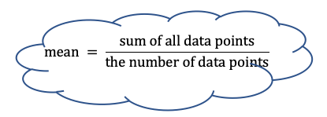
Mean – The average value determined by sharing the sum evenly among the values in the set.

Ex. 1) Calculate the mean for the data set 4, 6, 7, 2, 10.

Ex. 2) The results of grade 7 math test were 87%, 85%, 92%, 98%, 100%, 89%, 95%. Is the mean a good representation of how the class did?

Ex. 3) Consider the data set 8, 4, 7, ____, 11. The mean of this set is 7. What is the missing value?

Ex. 4) In ten basketball games, Christy scored 15,7,9,12,11,3,8,9,18,14 points. Her coach wants to know the typical number of points that she scores.

A.) Determine the mean score: ___________________________

B.) Determine the median score: ______________________________

C.) Determine the mode: _______________________________

D.) Determine the range: _________________________________

E.) Mean, median, mode, or range, which one would you use to determine the typical number of points Christy scores during a game? Why?

ASSIGNMENT: ___________________________

8.5 Outliers

Outliers – A data value that is far from the other data values.

Ex. 1) Plot the data given in the table on p356 on a line plot. Identify any outliers.

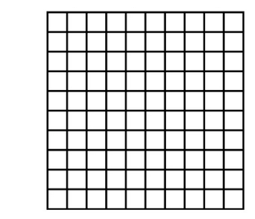

Ex. 2) Jill entered a math competition and received the results below.

- Show the results on as a broken line graph.

55%, 99%, 75%, 75%, 75%, 82%, 90%, 84%, 88%, 80%

- She has two options for calculating his final score:

Option A: Calculate the mean without the least and greatest value.

Option B: Calculate the mean of all the marks.

Which one should she choose?

ASSIGNMENT: ___________________________

11.1 Interpreting Circle Graphs
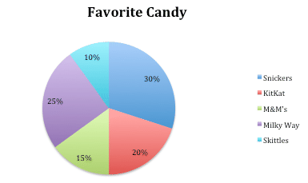
Circle Graph – A graph that shows how parts make up the whole.

Ex. 1) There were 120 students surveyed.

- How many liked Snicker’s?

- How many liked Skittles?

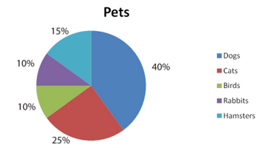

Ex. 2.) Students were asked their favourite pet.

- If 36 students favourite pet is a hamster, how students were surveyed?

- How many students’ favourite animal is a dog?

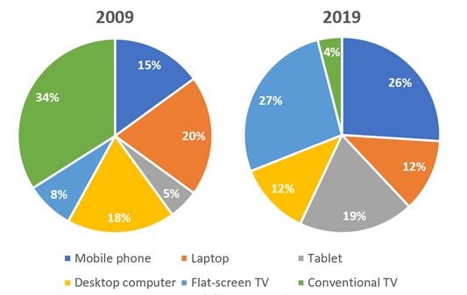
Ex. 3) The graph on the right shows how viewing habits of young adults have changed in Canada over time.

- How might this graph look if the survey was done today on students?

- Which type of device has decreased in popularity the most?

- Can you tell how many people were surveyed from the graphs?

- About how many times more popular is the mobile phone in 2019 compared with 2009?

- If 1000 people were surveyed, how many fewer people use a desktop computer in 2019 compared with 2009?

ASSIGNMENT: ___________________________

11.3 Constructing Circle Graphs

Ex. 1) Collect data from the class and construct a circle graph to represent the data.

Favourite ___________________ | # people | % of whole | Degrees
TOTAL

Sample Calculations:

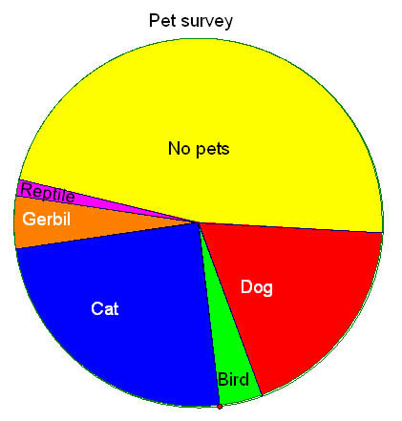
Ex. 2) 120 students were surveyed about their pets.

- What percentage have no pets?

- How many have dogs?

- How many have birds?

ASSIGNMENT: ___________________________

